# [Why Law And Order: SVU Season 22 Won't Resolve The Big Trial Cliffhanger Right Away](https://www.cinemablend.com/television/2553909/why-law-and-order-svu-season-22-wont-resolve-the-big-trial-cliffhanger-right-away)

* + [**LAURA HURLEY**](https://www.cinemablend.com/author/laura-hurley/)

PUBLISHED: SEP. 2. 2020 5:51 PM

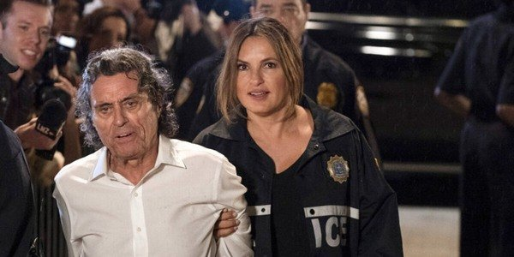

Like many network shows at the end of the 2019-2020 TV season, *Law & Order: Special Victims Unit* had to wrap several episodes [**short of the intended finale**](https://www.cinemablend.com/television/2492950/updated-list-of-major-tv-show-delays-or-ending-early-due-to-coronavirus). The episode that did wrap Season 21 ended on [**more than one cliffhanger**](https://www.cinemablend.com/television/2495049/how-law-and-order-svus-season-21-finale-left-things-with-fin-and-rollisi), so it actually worked out. Unfortunately, at least one [**won't be resolved**](https://www.cinemablend.com/television/2495070/law-and-order-svus-peter-scanavino-explains-season-21-finales-big-rollisi-scene) right away when *SVU* returns for Season 22. Showrunner Warren Leight revealed that answers about Sir Toby will have to wait.

In response to a question on [**Twitter**](https://twitter.com/warrenleightTV/status/1300857371011485696) about whether *Law & Order: SVU* will pick up with the trial of Sir Toby Moore, Warren Leight shared:

**I can answer this... no it won't. A lot has happened since we shut down, in New York, and in our country. First few eps will see our squad grappling with many of the losses and changes and challenges we're all going through at this moment.**

According to Warren Leight, the early episodes of *Law & Order: SVU* Season 22 will focus on how the squad handles the challenges of current events, which fits with his previous confirmation to [**THR**](https://www.hollywoodreporter.com/live-feed/tvs-top-5-a-conversation-police-hollywood-law-order-svu-showrunner-1297222) that the show will address the COVID-19 pandemic. The trial of Sir Toby Moore was only just starting in the Season 21 finale, with the proceedings halted when Toby seemingly suffered a cardiac event, although the question of whether he was faking it was very much unanswered.

If the show is going to tackle COVID storylines, it stands to reason that a sensational trial like that of media mogul Sir Toby wouldn't happen as intended. I also wonder if Ian McShane's availability is part of what has led to a delay in continuing Sir Toby's story. What's not clear at the moment is whether *SVU* will pick up in real time for Season 22, which would mean missing out on a lot of what happened with COVID in New York in the spring and summer.

*SVU* is about sexually based offenses and the victims, not medical crises, so I wouldn't be surprised if the focus is much more on the characters and cases rather than the pandemic itself. However Warren Leight might have intended to end Season 21 and begin Season 22, plans have had to change. That said, the early absence of Sir Toby doesn't mean that Season 22 will be anything to miss. The upcoming season will [**feature Christopher Meloni**](https://www.cinemablend.com/television/2495505/chris-melonis-stabler-is-returning-to-law-and-order-svu-universe-way-sooner-than-expected) as Elliot Stabler for the first time since he left *SVU* at the end of Season 12.

While a reunion between Mariska Hargitay's Benson and Christopher Meloni's Stabler is something that longtime *Law & Order: SVU* fans have undoubtedly been hoping for since he first departed, he's not returning to *SVU* to resume his partnership with Benson on a full-time basis. That said, the odds of more appearances back on *SVU* are pretty great.

Christopher Meloni will star in [**his own *Law & Order* series**](https://www.cinemablend.com/television/2550230/what-christopher-meloni-thinks-of-stabler-and-benson-reuniting-for-law--order-svu-spinoff) set in New York City, so his path should cross with Benson's on a far more regular basis than once every decade or so. The pandemic that is preventing Sir Toby's trial might also put a damper on their reunion, but I will take [**any and all Stabler/Benson**](https://www.cinemablend.com/television/2551018/chris-meloni-talks-being-inextricably-linked-to-svus-mariska-hargitay-and-olivia-benson) that *SVU* will give me!

Although Stabler's *Law & Order: Organized Crime* has been [**pushed back to 2021**](https://www.cinemablend.com/television/2553456/law-and-order-organized-crime-and-3-big-nbc-premieres-that-are-now-delayed-until-2021), *Law & Order: SVU* has finally received a premiere date for new episodes. Season 22 will begin on Thursday, November 12 on NBC, just one day after [**the other three shows**](https://www.cinemablend.com/television/2494640/nbcs-one-chicago-ranking-fire-pd-and-meds-season-finales) in its shared NBC universe return to the airwaves. For more of what to expect in the coming months, check out our [**2020 fall TV premiere schedule**](https://www.cinemablend.com/television/2549136/2020-fall-tv-premiere-schedule-list-of-new-and-returning-shows)!